**Name of team members**

Surya Chandrasekaran

Sujith Polpaya

Nicholas Fong

Vikas Shetty

**Title of your project**

Collision Avoidance And Speed Warning In Cars

**Block diagram**

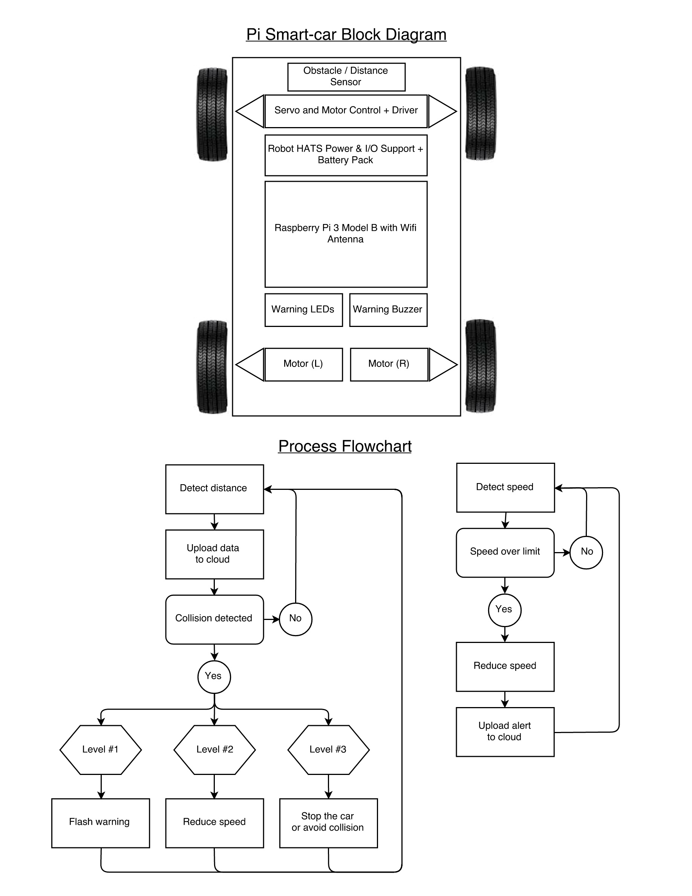

**Bill of materials**

(NEED TO ADD)

**Description of application**

The purpose of our project is to provide a safety mechanism to avoid collision while traveling at high speeds. We intend to achieve this by notifying the drivers of both cars while they are driving so that they can know how close they are in colliding with the other car and therefore take preventive action at that specific instant. The notification process is done by using LED lights and a buzzer that will be mounted on the car.

As the car is traveling the obstacle sensor detects if there are any obstacles (vehicles, rocks etc) that are present near the car. The distance between the car and the obstacle is calculated and sent to the cloud for analysis which determines if or not a collision may occur. If there is a chance of collison then a warning is sent to the driver.

We have used three different levels of notifying the driver about a collision.

**Level 1**

The red LED light will be flashed to indicate a possible collision. An alarm with the message "Warning! Collision possible." is also set in this situation.

**Level 2**

The speed of the car will be reduced to 70% ( or .x ) of its current speed in order to allow the driver to control the car thus preventing it from any possible collision.

**Level 3**

As the driver does not react to the slowing down of the car, the car then comes to a halt immediately. This totally prevents the collision from happening.

**Speed Control**

We notify the driver using LED and buzzer if they exceed the speed limit value that is predefined by them. The current speed of the car is collected from a speed sensor.

**Preferred development Board**

Raspberry Pi

**Programming languages:**

C/C++, Python

**Milestone ( Time line ) – Weekly**

Milestone 1: Initial setup and Equipment Gathering Phase : (Week 1)

* Set Up the Raspberry Pi Board.

* Research about the MQTT server setup.

* Gathering all the required equipment for the project.

* Coming up with a high level design plan.

Milestone 2: (Week 2 & 3)

* Getting the basic control of the car.

* Should be able to integrate the proximity sensor with Raspberry Pi Board.

* Research regarding industry standard for Automatic breaking system and proximity detection in autonomous cars.

* Doing an initial study about cloud integration.

Milestone 3:  (Week 4 & 5)

* Come up with basic code for controlling the car and getting the proximity sensor data.

* Setting up a three-level alert system.

* Integrating user alert system (either LED light or a Buzzer)

* Testing the basic use cases.

* First Demo and getting inputs from professors. (End of Week 4)

Milestone 4 : (Week 6)

* Implementing inputs provided by the professor.

* Completion of coding for the three-level alert system.

* Setting up cloud connection and showing user data.

* Testing the entire system end to end.

* Working on add-on features

* Second Demo to professors.

Milestone 5: (Week 7)

* Bug fixes.

* Testing final demo car in a controlled environment.

* Data analytics using cloud data gathered.

* Completing detailed documentation for the entire system.

* Final demo.